Industry Overview
- What are the types of services it offers exactly- what is its revenue model?

Main tech- trapped ion systems.
History
- 2 decades of research to build this up
- Accenture collaboration (2yrs)
- Evaporated glass traps (2 yrs)
- IPO for them was just a means to raise money essentially.
- Company partnership dates
- Collaboration in financial computing: multiverse computing. Fraud detection from Astro to finance, accessibility to quantum computers for those in financial fields will be grossly improved.
- AI Boom dates
- Collaboration with academia: duke. Nqbit fully gate. Ionqs gate more efficient- new technology discovered for solving complex algorithms.
- IonQ aria brought to Microsoft Azure platform
- Hundai project announcement
- Sept 2022- Airforce contract secured 13mn
- Sept 2023 – Another airforce deal 25mn this time
- IonQ Aria on AWS
- Other IonQ services launching times.
- IonQ Forte Launch
- Enterprise launch in 2024 and other launch in 2025

Slide
We sit at the middle of quantum, Chicago quantum exchange, as part of tbc I would say that we have some duty to understand this first.

Tech -- Deep tech: the future model for disruption: in most cases in history a company transitions as a disrupter backed by VCs etc and goes public much much later when they need capital for more intensive things. Here it is completely different, you essentially have the ability to be a part of a disrupter from the onset because they need that cash. TRANSITION FROM TECH TO INDUSTRIALS. THIS IS THE INDUSTRY OVERVIEW OF THE FUTURE, THIS IS A COMPANY THAT SERVES AS THAT LINK TO MAKING THAT POSSIBLE. This is the first time when such a long research project plays out you can massively gain in on it.

Another reason why they are different the physics has already been figured out- taken 20 years to get here.
Another reason why different- cloud computing.

Forget about TBC, realistically outside of everything this is the future.

Overview of the industry
- History of quantum computing
- Academia rather than industry and how this is tied to Accenture collab
- Deep technology integration
- UChicago
- Projections for the quantum industry itself (and why x% share would determine its market price accurately, that is also a consideration in my bear and bull case)
- Why is the future quantum
- Why IonQ is the future of quantum
- First pure play quantum computing company to be listed
- Weird because they are one of the few companies like this actually listed
- Why IonQ is undervalued

Investment Thesis

I am not going to be focusing as much on technical analysis as much as on the bigger picture and the underlying value creating opportunity for this company. There is no other company that can be a return for the amount of time and the diversification in terms of offerings as IonQ. Intrinsic value is good when you have a company with an established revenue model, not a disruptor like this.

All objections are valid if this was like $20 or something, but its literally half of that. The possibility for value creation here is beyond immense.

A market ripe for disruption, a company geared for innovation, and the untapped potential of quantum powered AI we present: With IonQ’s Technological advantage, strategic collaborations, and the industry’s forecasted growth, there is a very compelling argument to be made for its valuation.

As low as its ever been, going to be launching two new products this year, not even realized the value of AI, literally as low as its ever been.

Revenue model is basically contract bookings- they don’t provide breakdown data for that.

Figures- Change in the net income over time, Change in the number of bookings, Revenue growth, stock performance with history etc, assets change, debt change

Maybe a slide with all the unique tech?

TECHNOLOGICAL PROWESS AND CLOUD COMPUTING MOAT
- Make problem with all quantum- noise- half of pme literally 3/4th functions to reduce this noise – IonQ unique in this matter. Superconducting qubits extremely struggle with scalability etc, they have the advantage of scalability + extremely low error rates.
Possible because of their development of virtual gates rather than needing physical gates.
- The other main problem which the rest of the world is solving- temperature- how IonQ solves this as well, HENCE TECHNOLOGICALLY SOUND.
- IonQ is not working on fundamental physics- the other competitors are the ones that are. Migrating out of an academic phase into an engineering and product phase.
- MOAT in the form of Cloud Service Opportunities: Anyone can access quantum computers through technology + AWS, Google Cloud etc. You don’t literally need to have a quantum computer on the premises if you want to use one. Cloud computing offers numerous moats? Only quantum hardware available on all major clouds. No other company available on more than one of these. INSANE competitive advantages. Only company available on all major quantum SDKs. (Interface that can connect any business to IonQs software and hardware) as a company you don’t have to build- you only want access to raw quantum computing power- which is what IonQ does.
- e/acc for deep tech depends on quantum computing. Essentially all of deep tech is connected to this company.
- Future applications scope: drug discovery, materials science, battery industry + new undiscovered options- applications are endless for a company like this- its like asking facebook back in the day how one would monetize the site- the opportunities here are endless and hence a technical analysis is useless.
- Existing access to softwares is insane. Quanum computing is not some far away fairyland for people, for other companies figuring out the physics it is, for IonQ, not so muchas they already have that figured out. I know your thinking like wait how is that possible we don’t have quantum computers surely right, well I would think again and look at this:
- Leadership quality :
Professors etc
Insane ceo
Head of Europe was the IBM head as well and recently joined
The quality of their leadership is immaculate. – me
- WHERE DOES IP FIT INTO ALL OF THIS: Honeywell vs IonQ is the perfect example of that.
Laser technology: IonQ has developed a proprietary laser technology that it claims is more stable and precise than the laser systems used by Honeywell. This could lead to higher gate fidelities and more reliable quantum operations.
Scaling approach: IonQ plans to scale its quantum processors by connecting multiple ion traps using a modular architecture. The company believes this approach will allow for more efficient scaling and the ability to create larger, more powerful quantum systems. Honeywell has not disclosed as much detail about its scaling plans.
Benchmarking results: IonQ has published benchmarking results showing high gate fidelities and long coherence times for its quantum processors. The company claims these results demonstrate the superiority of its technology. However, it's important to note that benchmarking quantum computers is a complex task, and different metrics may favor different systems.

PROPELLED EXPANSION OF ADRESSABLE MARKET
- Applications in AI: As AI reliance increases, there is bound to be an increase in dependence on quantum computers over classical computers with the desire for superior computational prowess. For machine learning and predictive AI. Find more news on this. The stock literally started trading 3 years ago at the same price and the same valuation. The potential it possesses in terms of rapidly increasing with the AI boom that we have seen has not been realized in its value. Quantum Machine learning- studying lithium compounds and their applictions in battery chemistry + collaborations with Hyundai, + new project announcements to utilize this machine learning – the future of autonomous vehicles requiring quantum computational powers since they have obviously been currently limited? Other applications- IonQ and GE working together on risk mitigation,

Microsoft Azure and Airbus collaboration- all of this means only one thing- the total addressable market is rapidly increasing + coupled with the expansion worldwide: Quantum Aircraft loading optimization project + future integration process

Hybrid Dell system. Transition to quantum hybrid quantum.

Opened the first quantum computing manufacturing facility in the us in Washington.

Goldman Sachs, DOE, UAE Quantum Research Centre Agreement, Fidelity centre agreement for development of scalable quantum state preparation for monte carlo simulations- monte Carlo achievements. Worlds first model for human cognition models being simulated- done with IonQ computing capabilities- huge potential for AGI.

- Military possibilities: Secured a 13.4 mn contract to provide quantum solutions to United States Air Force Research Lab, DARPA has not yet got involved in these projects as far as we can tell, and tha is when big money starts rolling in. applications to cryptography- QKD. In Sept 2023 Again air force deal- expanded partnership.

Why a lot of these thesis are interconnected.

- Losses vs how much they have in cash is an important distinction to understand.
- The Margin of safety is immense, it is very very unlikely that a quantum computing company that is offering services, that is beating revenue predictions, and that is part of probably a great part of the future like the quantum industry, the only way forward is up.
- The stock literally started trading 3 years ago at the same price and the same valuation. The potential it possesses in terms of rapidly increasing with the AI boom that we have seen has not been realized in its value.

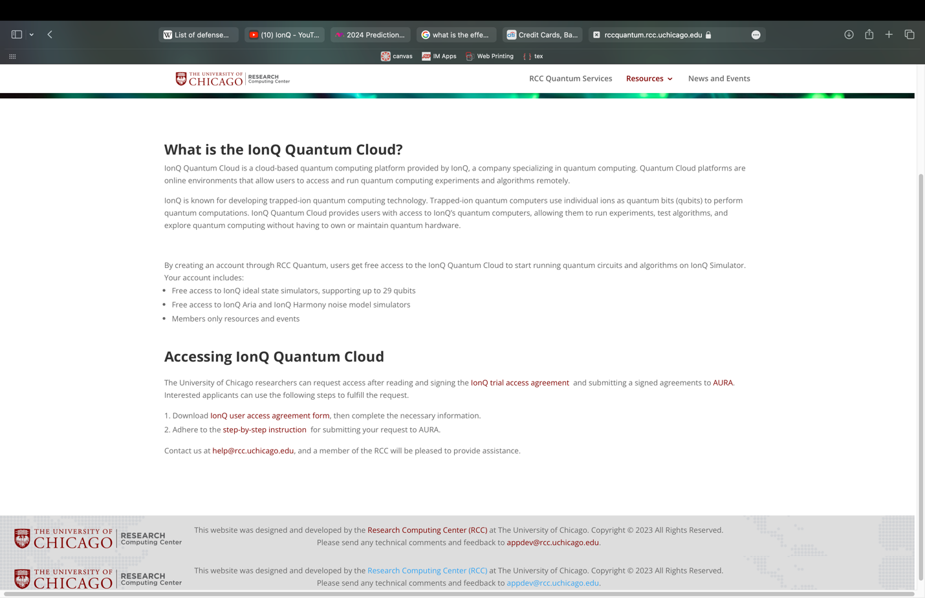

THESIS: Market overemphasizes valuation fundaments blinding it from the potential of value creation.

- How far away the competition is in terms of scalability and realization of the science is not even funny- psi quantum trek visit
- Relative valuations considering the potential of quantum conputing: consider what different prices for the stock would mean in terms of valuation.
- Solid fundamental financing not fundamental cash flows make it the best blue chip because of overreliance on technical analysis- the most obvious question that comes up is if this is that good a company then why does no one want to buy it, I think there is an overreliance on fundamental valuation mechanisms and intrinsic valuation that blinds the possibility of value creation for IonQ.
- Balance sheet looks v v good, very little debt and great number of assets, but the income statement is what needs the work. You are essentially buying the balance sheet and the cash. Interest payments don’t affect this stock- it has barely any debt and the fact is that it can be utilizing the cash that it has to produce eve more money effectively. SHORT SQUUEZE- 26.87% of shares owned are shorted. Intrinsic value market value blah blah – even good company at high price not worth it- the goal of value creation in mind this is ideal.
- MARGIN OF SAFETY CHART
- Not only overemphasis on the fundamentals but also there seems to have been some previous shorting frenzy that is very likely to get squeezed out soon.

I actually bought 10k of this stock yesterday so yes Im betting good money on this. Citation

Risks
- Tech giants entering the market - it’s a who’s tech is better play - cite the source that name ionq the best in terms of speed and processing power or what not. Hardware and software outperforms the field. Even if you are a tech giant you can’t replicate those many years and that much of work having been done in an academic setting.
- ⁠
- ⁠ai thing - other companies have had this realise- psi wuantumb value at 4bn for what exactly?
- ⁠d space and Rigetti market analysis of how none of them have survived.
- ⁠the high profile backers Google aws etc make u less concerned about the technical part of the problem

Risks: Outstanding warrants. Not produced a scalable quantum computer and faces barriers to produce them.

Pictures at the end: PME, PSI Quantum, e/acc, deep tech shit

No long term debt which is insane compared to everyone else in this market.

